Date
Institution
Date
“BACK TO THE ROOTS” MUSHROOM PROJECT

Introduction
“Back to the roots” represents an entrepreneurial journey by two business students focusing on the production of mushroom. In their first step, they worked on the provision of mushroom growth medium specifically being the coffee husks available from processing companies throughout the area. The coffee ground has been widely used in many parts of the world such as Africa and the Caribbean to fight the problem of malnutrition (Calderon, Bagadia, 2015).
The coffee ground is preferred because they possess the right amount of moisture for the growth of mushrooms, it’s sterilized through processing and contain the required amount of cellulose. Additionally, the material occurs as a residue in the process and hence it occurs as an unwanted material in the production site. Therefore, the entire process involves turning waste into a productive resource (Calderon, Bagadia, 2015). The roll-out of the program, however, did not occur as planned as the trial experiment conducted resulted in more contamination as nine of the ten test buckets occurred as spoiled. The produced amount was however taken to a restaurant and confirmed to be high quality. From this point, the team sought on a mechanism of actualizing their project by partnering with various bodies from coffee ground producers to consumers. This project was a development of the initial plan as the team wanted to supply the coffee residue to mushroom farmers to supplement their materials for growing high quality produce. After the market scan, however, Velez and Arora realized that farmers were not ready to pay much for the material. The idea was then changed for them to use the coffee material themselves and supply high-quality produce.
Distributor of Growing Medium for Mushroom Farmers
The project by the two students began as an idea to distribute coffee waste material to mushroom producers. The students, however majoring in business had identified the venture as profitable after an insight by a visiting professor. With less knowledge of mushroom and agricultural practices, the two individuals felt at a disadvantage but worked hard to ensure that their final year initiative would become their source of livelihood. The production of coffee is an expensive process in the industries depending on the quality and final product required. In the process, only 0.02 of the entire coffee bean is used in producing coffee the rest becoming residual unwanted material (Rattan et al., 2015). The individuals then formed a collection route for coffee material for selling to the farmers. The material would replace the medium farmers used in production. The team, however, realized that the supply of the material would lead to losses as farmers were not ready to pay much for the material. Largely, the project would lead to losses comparing the inputs such as transportation costs to the final income. Arora and Velez realized that they had to change their business model concerning mushroom production through the use of coffee waste material.
Urban Organic Mushroom Farmers
Velez and Arora realized that the initial plan couldn’t work and they were forced to study the requirements for mushroom production as they settled on venturing into mass production. Velez used his kitchen to run growth tests learning from you tube videos, and agricultural experts. The project changed drastically from the market scan conducted over the short period. To successfully roll out an idea in the market various factors have to be considered relating to the type of innovation, the relationships, timing, and entrepreneurship. These factors are represented as an innovation-entrepreneurship framework.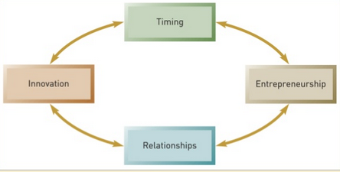
Fig 1: Innovation-entrepreneurship framework.
The framework however simple shows aspects that have to be considered to ensure that an idea serves the market need. Arora and Velez were able to identify the challenges in the distribution process early enough before investing in the venture and thus modified the project to raise productivity.
Do-It-Yourself Mushroom Kit Producers
The success of the project, serving different restaurants resulted to interested parties enquiring on the process of mushroom production. The team working with Whole Foods purposed to make simpler kits for customers to row their own mushrooms as large-scale agricultural production presented its own challenges. The innovative idea thus was to enhance production by increasing the number of producers. The most important aspect was a design that could be sold at relatively low prices that would be preferred by the customers (Calderon, Bagadia, 2015). This move was an empowerment of the society with the technology adopted in 11 different states within three months. The group now had a different vision of impacting the society. There are various aspects that led to the development of the business model. Velez and Arora wanted to bring many people on board and therefore that gave them a prose of providing high quality produce that would occur as the best in the market. Additionally, the group sought advice and guidance from different players in different fields a factor that led to resolving complexities in areas such as agricultural production, supply, marketing, financing among many others. The group’s decisions were made unanimously as they players adapted to the changes in the market relating to customer needs. The causes of growth ca be attributed to many factors in addition to the management model. These factors are represented by the figure shown below.
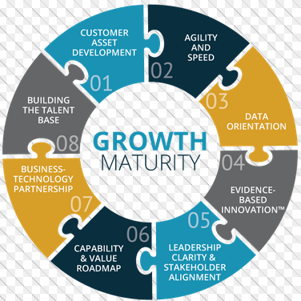
Fig 2: Mushroom Business Growth Factors
Do-it-yourself sustainability education
The BTTR program worked appropriately as planned expanding its base to different regions and diversifying the practices. The pair of students had initially been exposed to mentorship program and hence most of their work related to community development. The program according to Velez would only be successful with the involvement and mentoring of other individuals and hence with the assistance of other players, the pair’s motive of social impact and education is achieved. Donations made by the team to schools lead to the production of mushrooms a fact that serves as a satisfaction to the team. Additionally, Velez and Arora have conducted various training, workshops, and fairs to influence production and sustainability (Calderon, Bagadia, 2015).
The move is a bold one as the group does not identify itself as a non-profit organization but a business. The operations of the BTTR has however influenced the model of the institution that has most of the operations dealing with society members and ways to raise production and sustainability. The most crucial aspect that BTTR has made in its operations is starting from the basics and assisting groups to grow and have a positive impact on the society. The initial customer acquisition efforts could have worked effectively with proper pricing deals and proper product descriptions provided highlighting superiority over what is in the market. Due to the nature of the market, competition is a major factor of concern, and therefore quality is the best way to go. Additionally, an aspect of an environmentally safe method of production would have worked as more people want to know their food’s point of production.
Back to the roots has played a critical role in the production, support, training, and empowerment of the society. Their approach has seen many people come on board by rolling out the use of simple kits.

References
Calderon, J & Bagadia, N. (2015). Case series: Back to the Roots Ventures. University of California, Berkeley.
Rattan, S., Parande, A. K., Nagaraju, V. D., & Ghiwari, G. K. (2015). A comprehensive review on utilization of wastewater from coffee processing. Environmental Science and Pollution Research, 22(9), 6461-6472.

